Nano Banana AI: Revolutionizing Creative Content Generation
By Sumaiya Ahmed

Introduction
Nano Banana AI is a strong tool that can turn text prompts into high quality images, voiceovers, songs, music and even films. It's a game-changer for designers, marketers, and content creators who need quick and top-tier creations. With its user-friendly interface and intuitive workflow, Nano Banana AI empowers users to create high-quality digital images, marketing materials, and game textures with ease and speed. Nano Banana AI is simple to use and requires no advanced design expertise, making it easy for users to create high-quality digital artwork, marketing materials and game assets.

Features of Nano Banana AI
Text to Image: Create realistic images from text descriptions, such as artwork, marketing imagery, product designs, etc.
Voiceover Creation: Users can create top-tier voice messages, which are ideal for creating audiobooks, podcasts, or digital marketing content.
Music & Song Generation: Nano Banana can create songs and music from written prompts, which is useful to music creators and advertisers.
Video Generation: As a content creator, the AI can also create videos which will help you improve your video content for social media, ads and websites.

Prompt:
"A cheerful woman cutting a birthday cake with colorful sprinkles in a cozy kitchen setting. The cake has the words 'BIRTHDAY SARAH' written on it with colorful icing. There are balloons and wrapped gifts in the background, with guests smiling and celebrating."
Optional Inputs:
- Style: Realistic, Casual, Fun
- Setting: Kitchen, Bright, Natural light
- Color Scheme: Bright, Colorful, Pastel tones
- Details: Include birthday decorations (balloons, colorful candles), happy people, wrapped gifts
- Lighting: Soft natural light coming from a window
- Mood/Emotion: Joyful, Celebratory, Warm

Output:

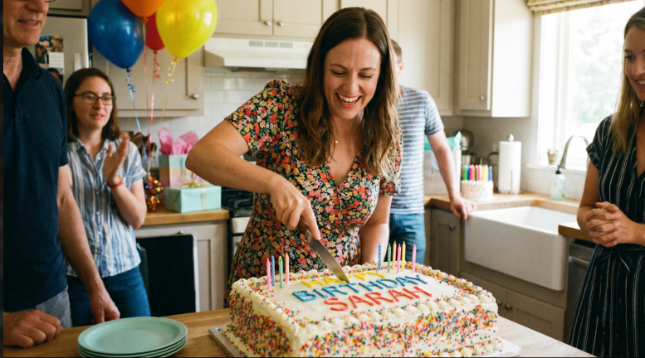
The image created is a bright and cozy kitchen depicting a celebratory scene for a birthday. The woman is holding a large cake with colorful sprinkles and the words “BIRTHDAY SARAH” written in bright icing, and she is smiling while cutting into the cake. Several balloons are seen floating in the background, and there are wrapped gifts on the counter, adding to the holiday atmosphere. She is surrounded by people who are smiling, and the scene appears to be filled with a soft, natural light that illuminates the area.

Prompt Engineering:
1.Describe things in detail.Describe things specifically.
- Clearly define the subject (e.g., appearance, clothing, expression).
- Explain the action or scene in detail.
- Specify some features (cake, balloons, gifts).
2. Add Optional Context
- Add lighting (such as natural, soft lighting).
- Include mood or atmosphere (e.g. cozy, celebratory).
- Explain any situation in the environment (e.g., kitchen).
3. Add Camera Angles or Perspectives
- Set the lens' focal mode (wide angle, close-up, etc.).
- Talk about focal points (close attention to the subject, background details).
- Describe an artistic style (realistic, cinematic, etc.).
- Talk about reference artists and overall visual trends.
6. Negative Prompts
- Point out items to stay away from (dark lighting, busy background).
- Give constraints to some of the visuals (e.g. don't use blurry visuals).

Conclusion
Nano Banana AI is a revolutionary tool that generates high-quality, professional visuals, music and videos from text prompts. The user-friendly interface and robust features make it a must-have tool for all creative professionals, offering efficient and cost-effective solutions without requiring any technical expertise or specialized software.

